CLO # 3: Understand the core theoretical concepts serving as foundations of ML algorithms
[20 wtg]
Q1. Answer the following questions briefly.
- Is clustering always meaningful? What happens if clusters overlap?
Clustering is not always meaningful. It is useful only when the data naturally forms groups.

If clusters overlap, it becomes difficult to clearly separate data points.

Overlapping clusters lead to:

Ambiguous cluster assignments

Reduced interpretability

Lower clustering quality
- Why are optimizers and batch size needed during model training?
Optimizers (e.g., SGD, Adam) adjust model parameters to minimize the loss function efficiently.
They control:

- Learning speed

- Stability of convergence

- Ability to escape poor local minima

- Batch size determines how many samples are used per update:

- Small batch → noisy but faster updates

- Large batch → stable but slower updates
- In Naive Bayes, why is it important for features to be conditionally independent? what is the role of the "prior probability" in classification?
- Naive Bayes assumes features are independent given the class.
Without this assumption, estimating probabilities becomes impractical.
Prior Probability
- The prior probability P(y)P(y)P(y) represents how common a class is before seeing data.
- It helps bias predictions toward more likely classes.

- After reducing a dataset using PCA, you observe that the features are uncorrelated. Explain why this occurs. Also, highlight the impact on model variance and bias when selecting fewer components.
Why features are uncorrelated

PCA projects data onto orthogonal eigenvectors of the covariance matrix.Orthogonality ⇒ zero covariance ⇒ uncorrelated features. Impact of fewer components Variance decreases (information loss) Bias increases (model becomes simpler) This creates a bias–variance tradeoff.
- How do we learn the parameters of the perceptron classifier using the training data? Provide pseudo-code of the perceptron learning algorithm.
initialize weights w = 0
for epoch = 1 to N:
for each (x_i, y_i):
if y_i * (w · x_i) ≤ 0:
w = w + η * y_i * x_i
- What happens if all base learners are identical in ensemble learning?
The ensemble gains no benefit No variance reduction Performance equals that of a single model Ensembles work best when base learners are diverse and weakly correlated
- “Stress level” has a positive weight in a model predicting blood pressure. How would this relationship be interpreted?
A positive weight means: As stress level increases, predicted blood pressure increases The model suggests a direct relationship. This does not imply causation, only association.
- How would you design a deep neural network to overcome the vanishing gradient problem? Justify your design choices.
- How do you choose the number of singular values to keep in singular value decomposition?
Choose k such that a high percentage of total variance (energy) is preserved. • Train your model using different k values
• Evaluate on validation data
• Choose k that gives best generalization performance

- Mathematically define the following kernel functions:
a. Linear Kernel
b. RBF (Gaussian) Kernel
CLO # 2: Formulate and execute solutions to the machine learning problems
[5+5 = 10 wtg]
Q2. a) Build a Naive Bayes classifier using the Bag of Words approach to assign labels to the last test documents. Use the dataset below, where each document is labeled as either Political or Non-political
Document | Category | Statement
1 | Political | the election is a match
2 | Political | very clean debate
3 | Political | the election is over
4 | Not Political | a close but forgettable match
5 | Not Political | football is a great game to play
6 | ? | a very close race

Not Political is slightly higher due to higher likelihood from words “a” and “close”

Q2. b) Refer to below table, you are tasked with predicting the likelihood of a new student passing the exam. The student has studied for 3 hours, scored 72 in Programming Fundamentals, and scored 60 in Linear Algebra. Using your predictive model based on the Gaussian Naive Bayes classifier, determine the likelihood of this student passing the exam.

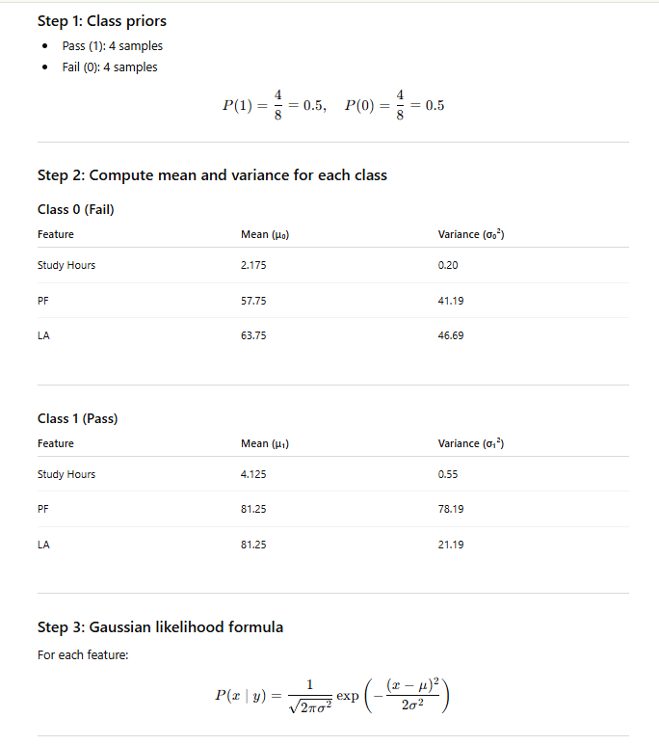

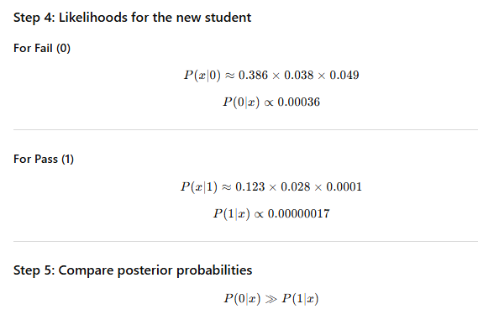

CLO # 3: Understand the core theoretical concepts serving as foundations of ML algorithms.
[5 + 5 = 10 wtg]
Q3. a) Imagine you are analyzing the similarities among five individuals named Alice, Brown, Carl, Dawn, and Eiza based on a specific characteristic (e.g., behavior, location, or feature set). The smaller the distance between two individuals, the more similar they are. Perform the agglomerative clustering step by step using a single linkage method. Visualize the process using a dendrogram. Calculate the Silhouette score s(i) for any one given data point. Here’s what the distance information reveals:
- A and B are the closest pair, with a distance of 2.00. They are more similar to each other than to anyone else.
- A and C are quite dissimilar, with a distance of 5.83, indicating a weaker relationship.
- A and D are also not very close, with a distance of 5.66
- A and E have the largest distance of 7.81, suggesting that E is the most dissimilar from A.
- Moving to B: Besides being closest to A (2.00), B is somewhat close to D, with a distance of 4.47.
- B and C are a bit more distant at 5.00, and B is also far from E (6.32).
- Looking at C, D, and E a group where distances start to shrink: C and D are very close, with a distance of 2.24.
- C and E are slightly farther apart, at 3.61.
- D and E also share a close bond, with the same distance of 2.24.
Q3. b) Perform K-means clustering algorithm using the Euclidean distance metric to the given datapoints A1 (2, 10), A2(2, 5), A3(8, 4), A4(5, 8), A5(7, 5), A6(6, 4), A7(1, 2), A8(4, 9). Initial cluster centers are: A1(2, 10), A4(5, 8):
- Assign each point to the nearest cluster center.
- Recalculate the cluster centroids. Repeat until the cluster assignments stop changing.
- Report the final cluster assignments and final cluster centers
CLO # 3: Understand the core theoretical concepts serving as foundations of ML algorithms.
[5+ 5 = 10 wtg]
Q4.a) The architecture in fig below is given as 𝑋 = [ −0.7 0.2 ], 𝑊 = [ 0.2, 0.5, −0.2, −0.1, 0.4, 0.6] , Ytruth = -1, and 𝜂 = 0.4. Using the backpropagation algorithm find the updated weights. (tanh for hidden and sigmoid activation function for output layer)
